Point - to - Point Protocol (PPP) is a communication protocol of the data link layer that is used to transmit multiprotocol data between two directly connected (point-to-point) computers. It is a byte - oriented protocol that is widely used in broadband communications having heavy loads and high speeds. Since it is a data link layer protocol, data is transmitted in frames. It is also known as RFC 1661.

Services Provided by PPP

The main services provided by Point - to - Point Protocol are −

* Defining the frame format of the data to be transmitted.
* Defining the procedure of establishing link between two points and exchange of data.
* Stating the method of encapsulation of network layer data in the frame.
* Stating authentication rules of the communicating devices.
* Providing address for network communication.
* Providing connections over multiple links.
* Supporting a variety of network layer protocols by providing a range os services.

Components of PPP

Point - to - Point Protocol is a layered protocol having three components −

* **Encapsulation Component** − It encapsulates the datagram so that it can be transmitted over the specified physical layer.
* **Link Control Protocol (LCP)** − It is responsible for establishing, configuring, testing, maintaining and terminating links for transmission. It also imparts negotiation for set up of options and use of features by the two endpoints of the links.
* **Authentication Protocols (AP)** − These protocols authenticate endpoints for use of services. The two authentication protocols of PPP are −
  + Password Authentication Protocol (PAP)
  + Challenge Handshake Authentication Protocol (CHAP)
* **Network Control Protocols (NCPs)** − These protocols are used for negotiating the parameters and facilities for the network layer. For every higher-layer protocol supported by PPP, one NCP is there. Some of the NCPs of PPP are −
  + Internet Protocol Control Protocol (IPCP)
  + OSI Network Layer Control Protocol (OSINLCP)
  + Internetwork Packet Exchange Control Protocol (IPXCP)
  + DECnet Phase IV Control Protocol (DNCP)
  + NetBIOS Frames Control Protocol (NBFCP)
  + IPv6 Control Protocol (IPV6CP)

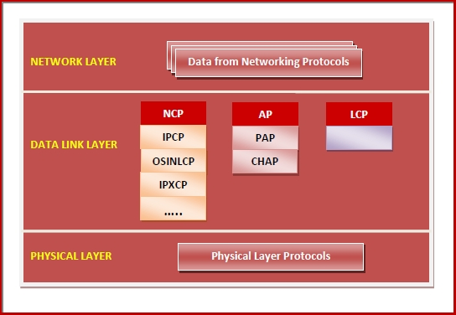

PPP Frame

PPP is a byte - oriented protocol where each field of the frame is composed of one or more bytes. The fields of a PPP frame are −

* **Flag** − 1 byte that marks the beginning and the end of the frame. The bit pattern of the flag is 01111110.
* **Address** − 1 byte which is set to 11111111 in case of broadcast.
* **Control** − 1 byte set to a constant value of 11000000.
* **Protocol** − 1 or 2 bytes that define the type of data contained in the payload field.
* **Payload** − This carries the data from the network layer. The maximum length of the payload field is 1500 bytes. However, this may be negotiated between the endpoints of communication.
* **FCS** − It is a 2 byte or 4 bytes frame check sequence for error detection. The standard code used is CRC (cyclic redundancy code)

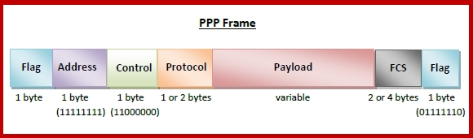

**Byte Stuffing in PPP Frame** − Byte stuffing is used is PPP payload field whenever the flag sequence appears in the message, so that the receiver does not consider it as the end of the frame. The escape byte, 01111101, is stuffed before every byte that contains the same byte as the flag byte or the escape byte. The receiver on receiving the message removes the escape byte before passing it onto the network layer.